Musawakhe Andrew Nzama

Bright Light Data Analytics Coding Practical

Practical 2.1: Advanced SQL

The following questions are designed to help you build a strong foundation in basic SQL syntax. You are provided with a dataset named shopping_trends.csv. Upload this dataset to your Snowflake account and use it to answer the questions below.

1. Find all records where Size is missing and purchase_amount > 50

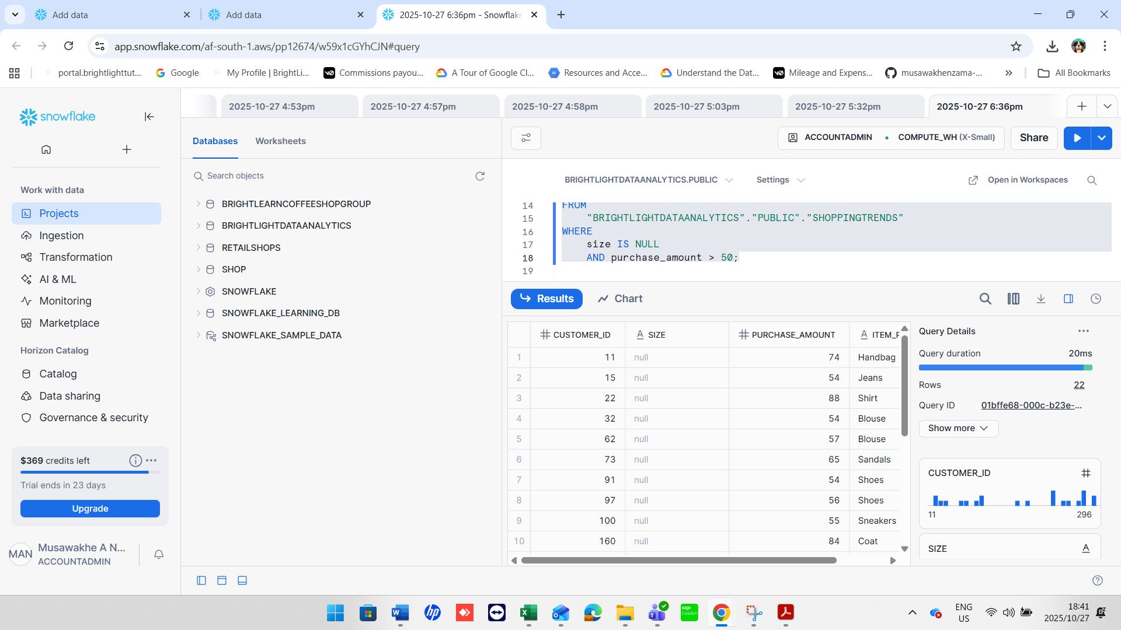

1. List the total number of purchases grouped by Season, treating NULL values as 'Unknown Season'.

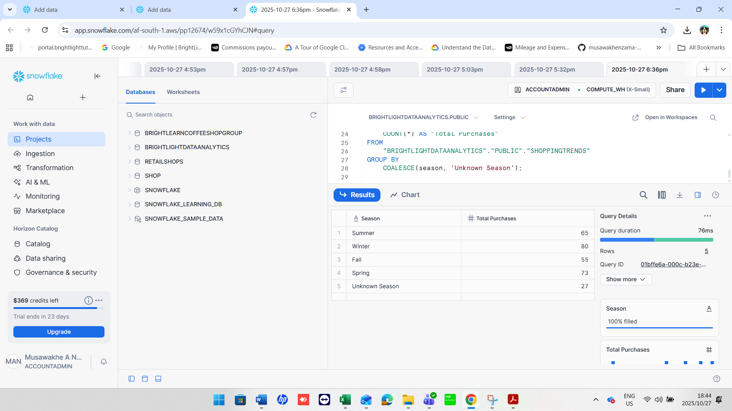

1. Count how many customers used each Payment Method, treating NULLs as 'Not Provided'.

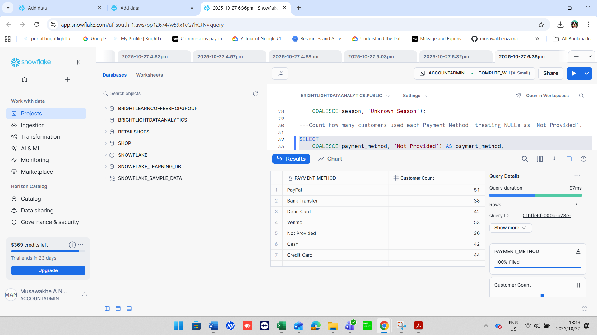

1. Show customers where Promo Code Used is NULL and Review Rating is below 3.0.

1. Group customers by Shipping

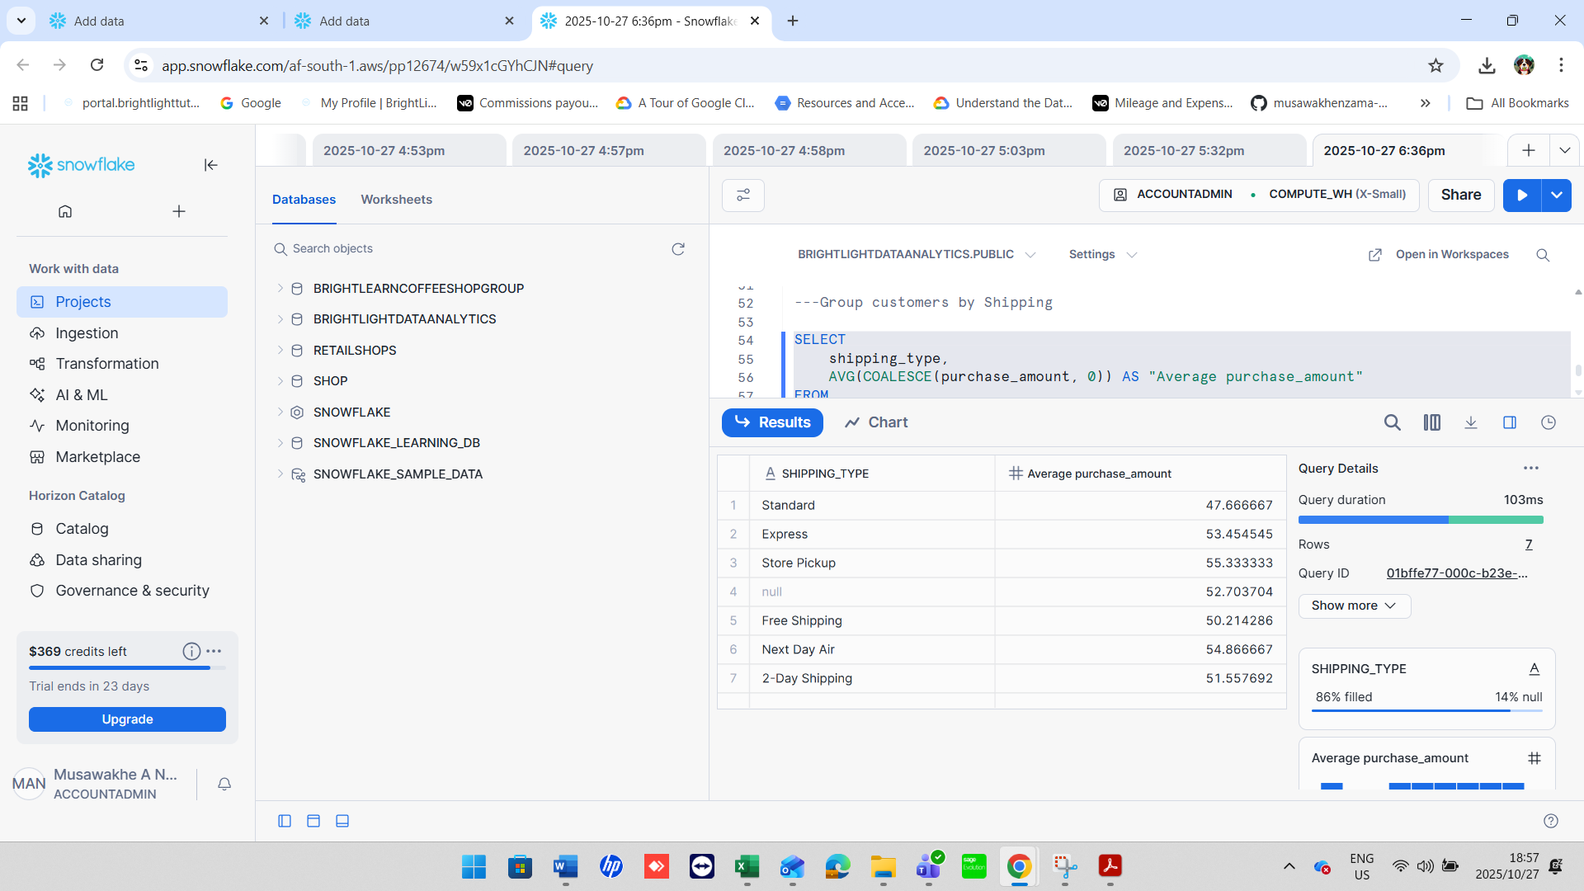

1. Display the number of purchases per Location only for those with more than 5 purchases and no NULL Payment Method.

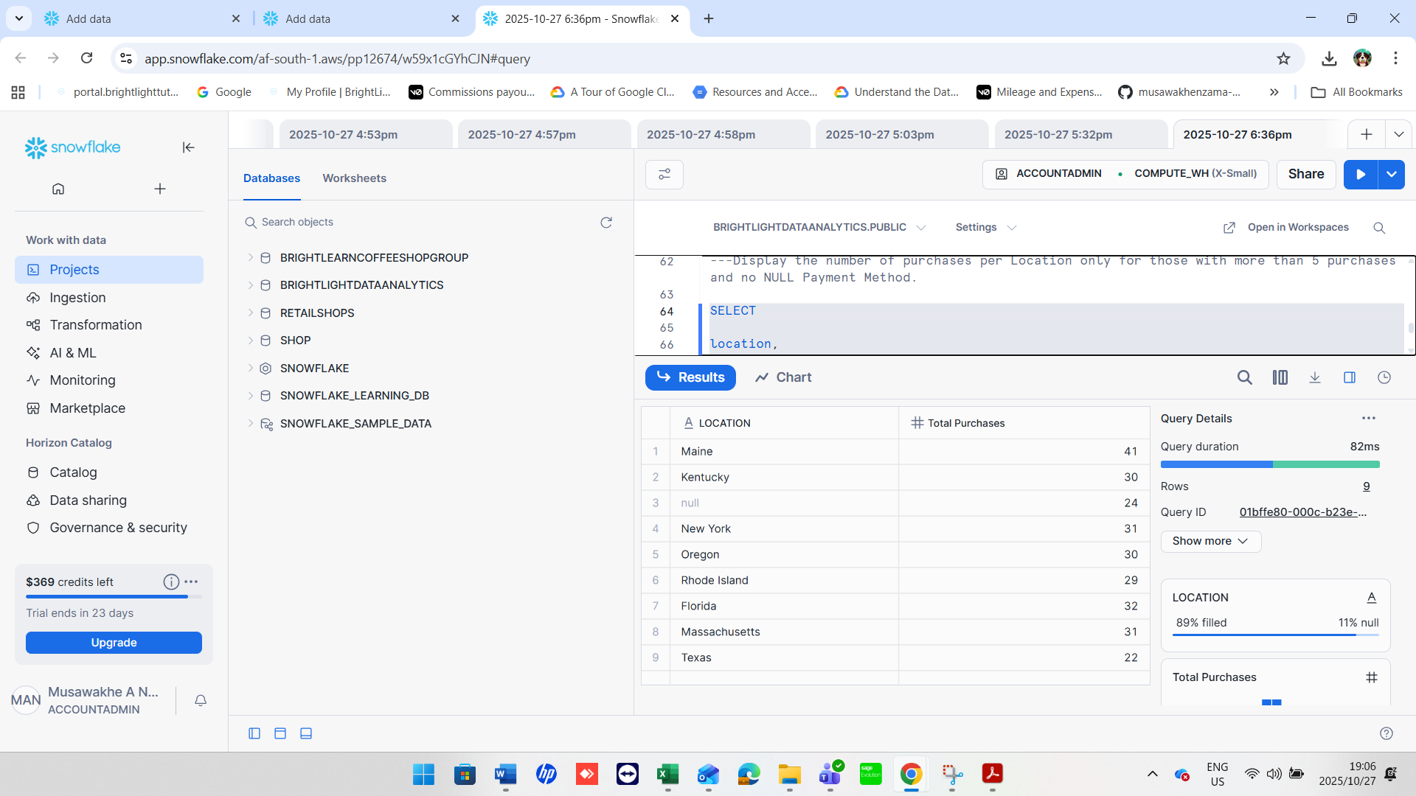

1. Create a column Spender Category that classifies customers using CASE: 'High' if amount > 80, 'Medium' if BETWEEN 50 AND 80

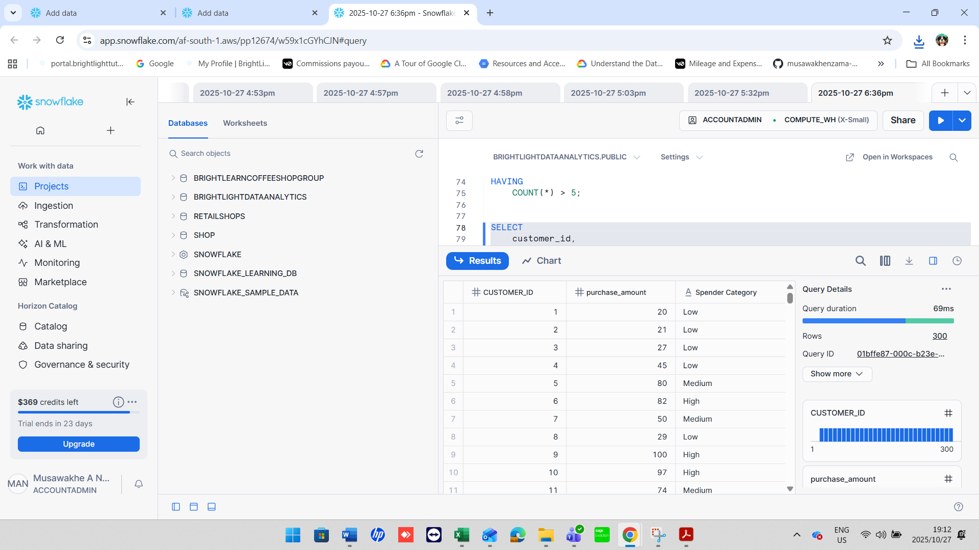

1. Find customers who have no Previous Purchases value but whose Color is not NULL.

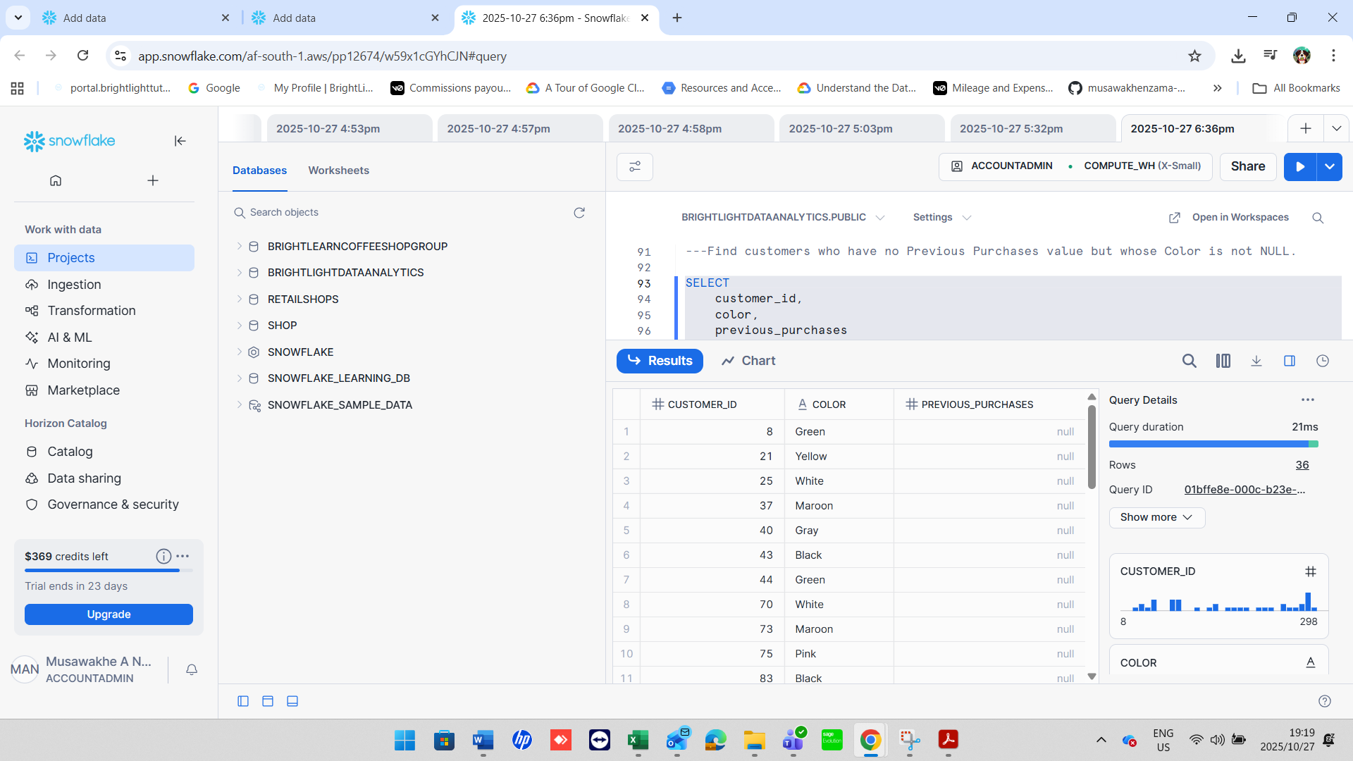

1. Group records by Frequency of Purchases and show the total amount spent per group, treating NULL frequencies as 'Unknown'.

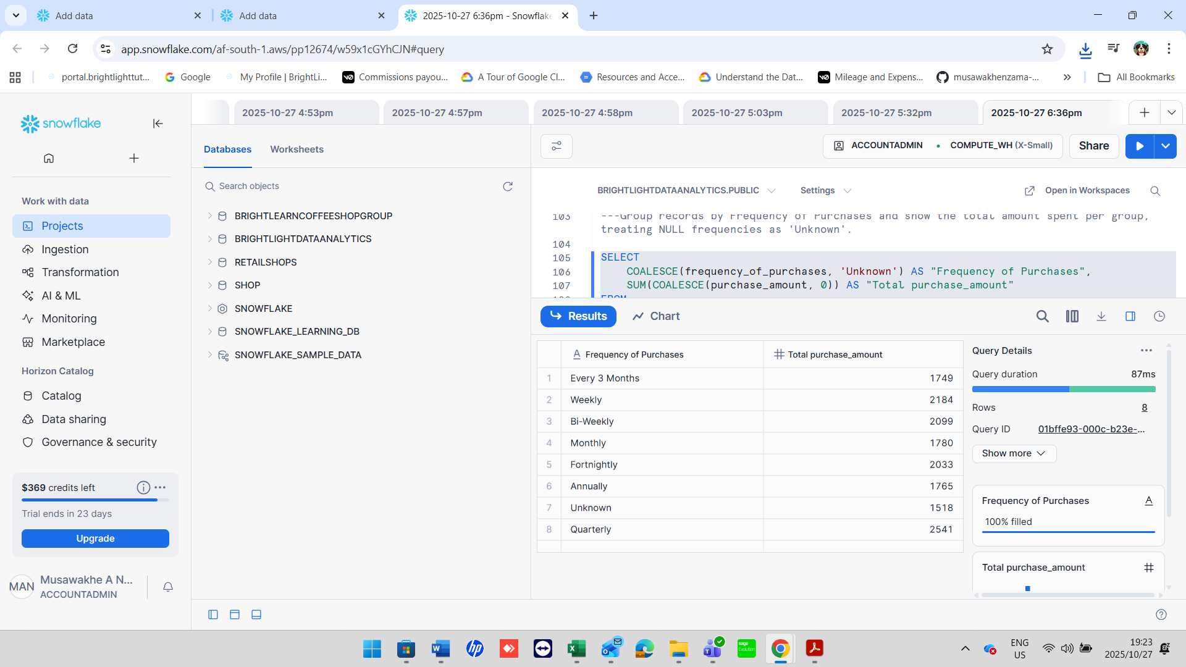

1. Display a list of all Category values with the number of times each was purchased, excluding rows where Category is NULL.

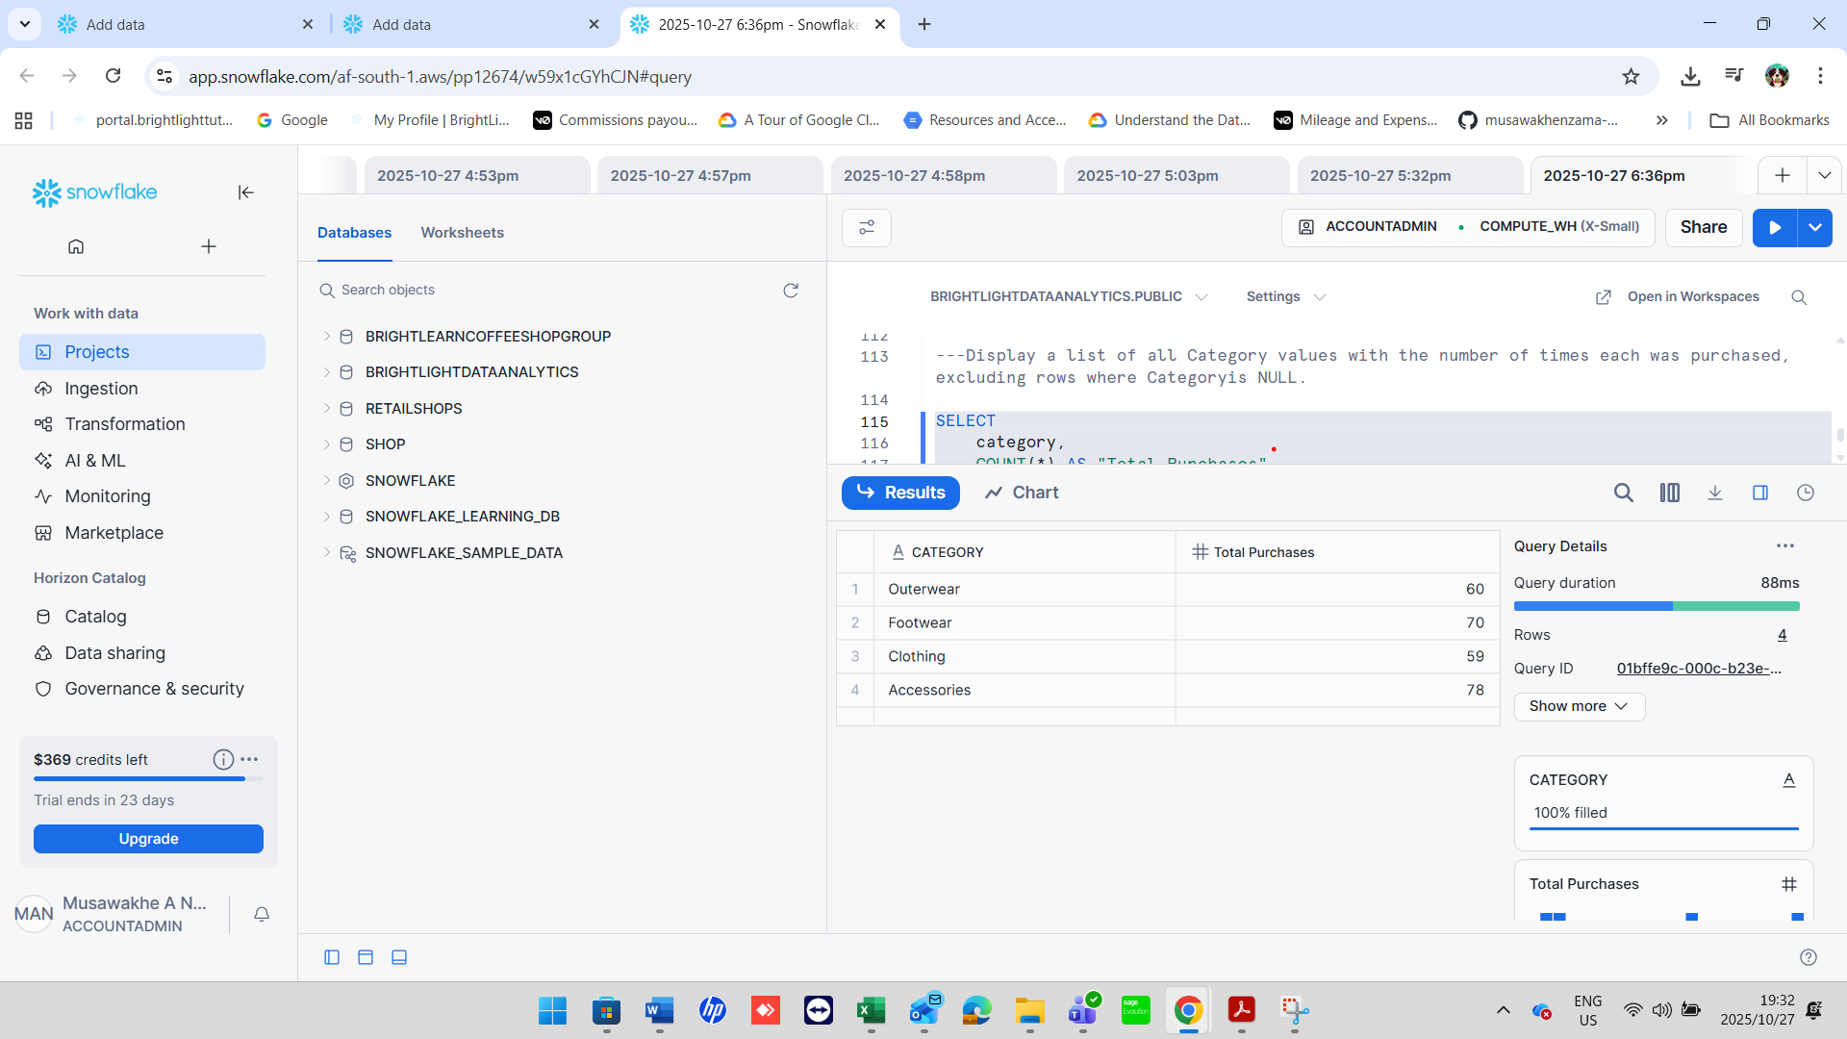

1. Return the top 5 Locations with the highest total purchase_amount, replacing NULLs in amount with 0.

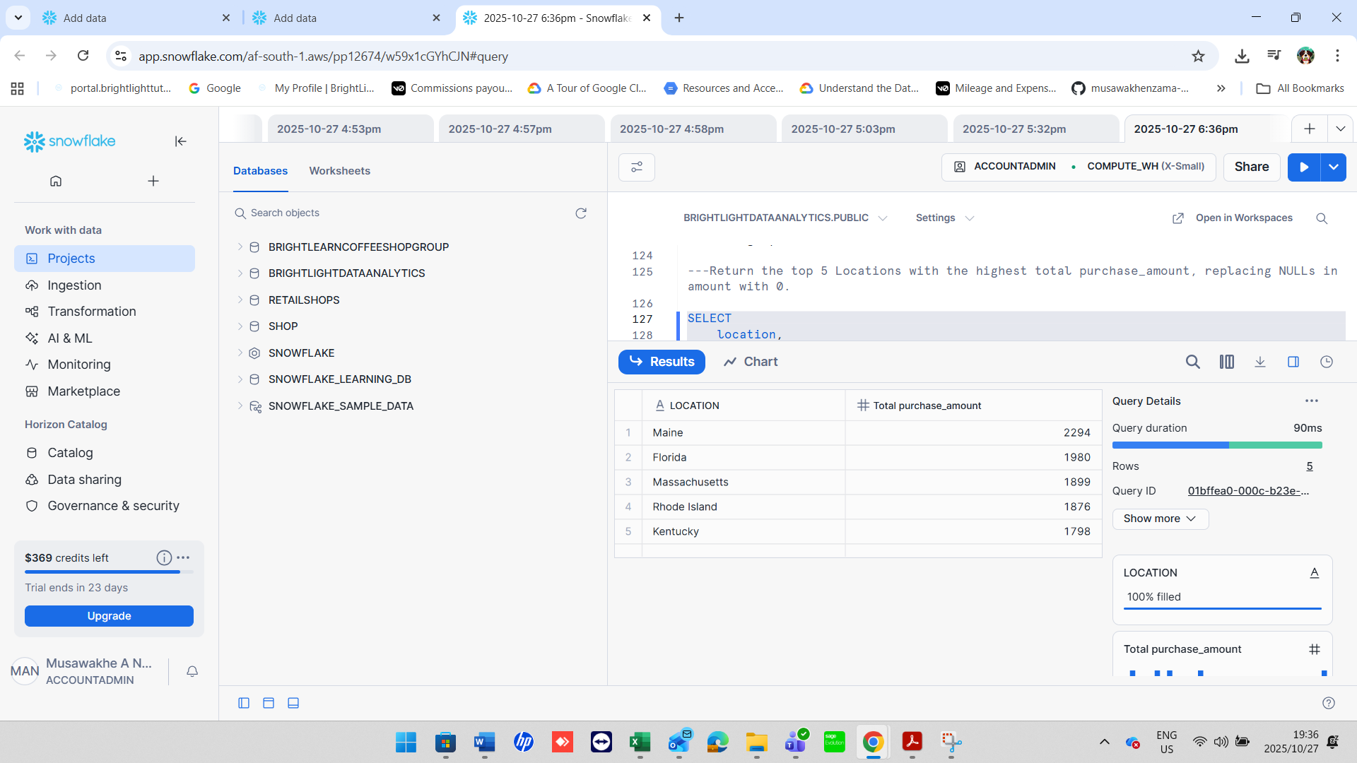

1. Group customers by Gender and Size and count how many entries have a NULL Color.

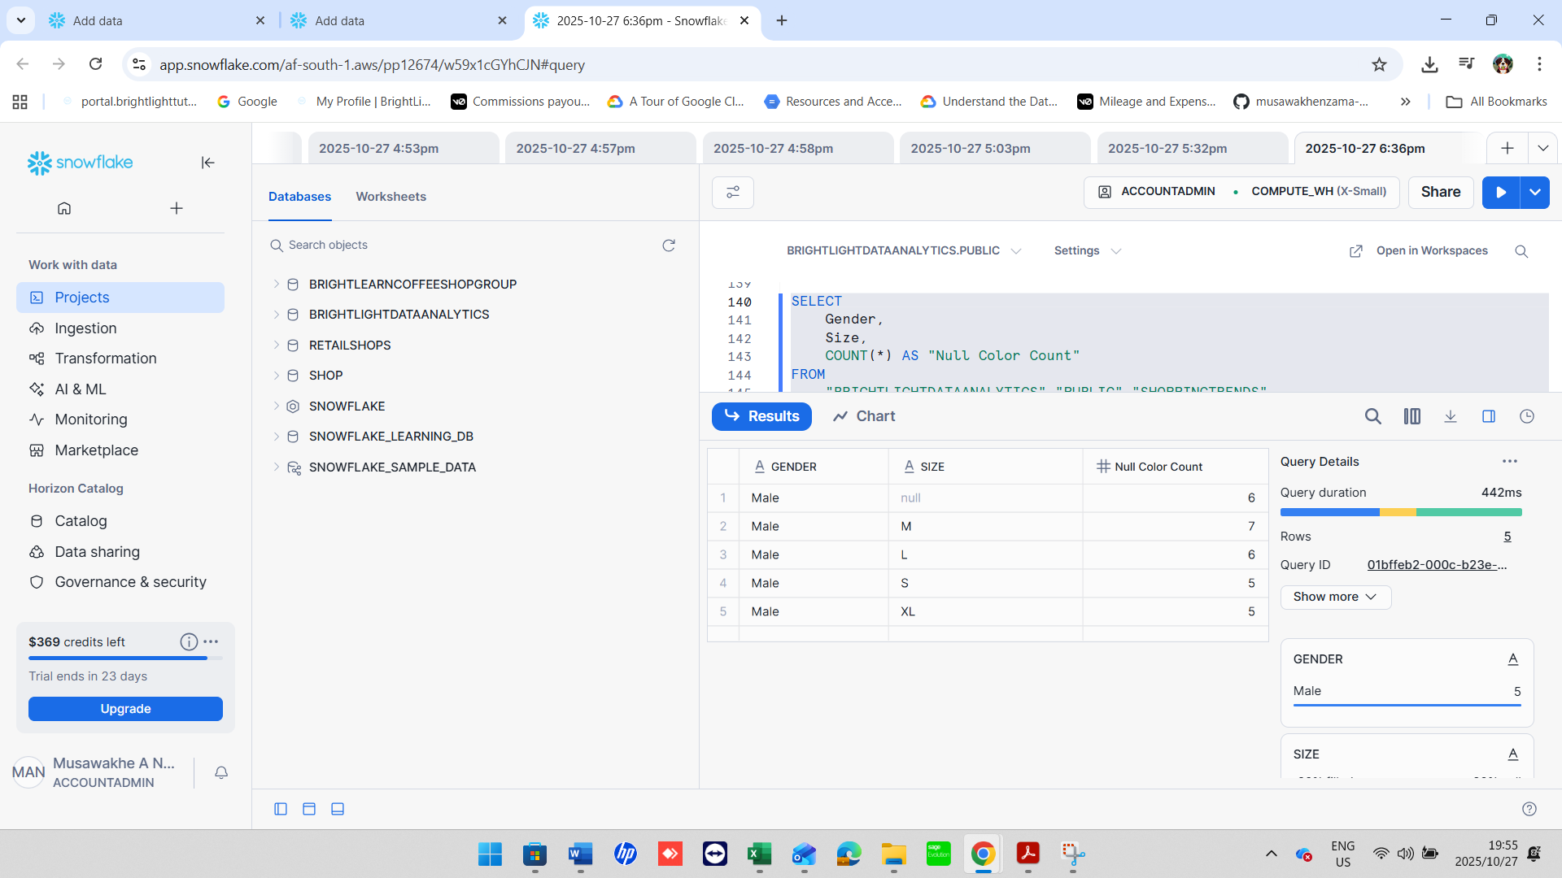

1. Identify all Item Purchased where more than 3 purchases had NULL Shipping Type.

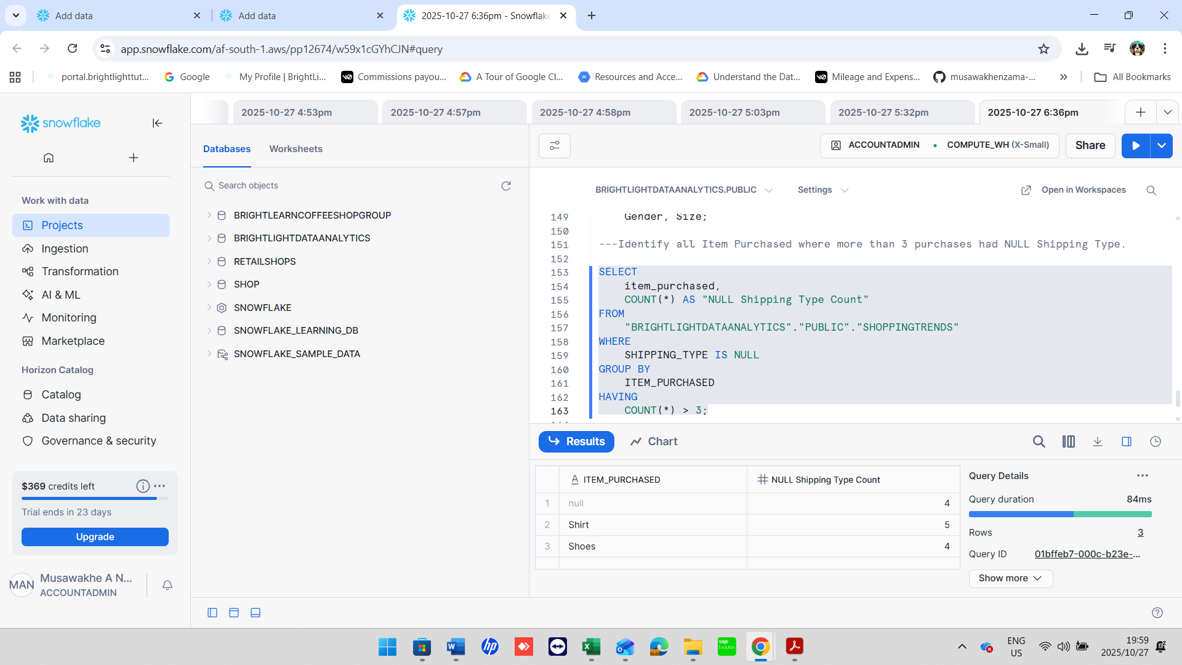

1. Show a count of how many customers per Payment Method have a NULL Review Rating.

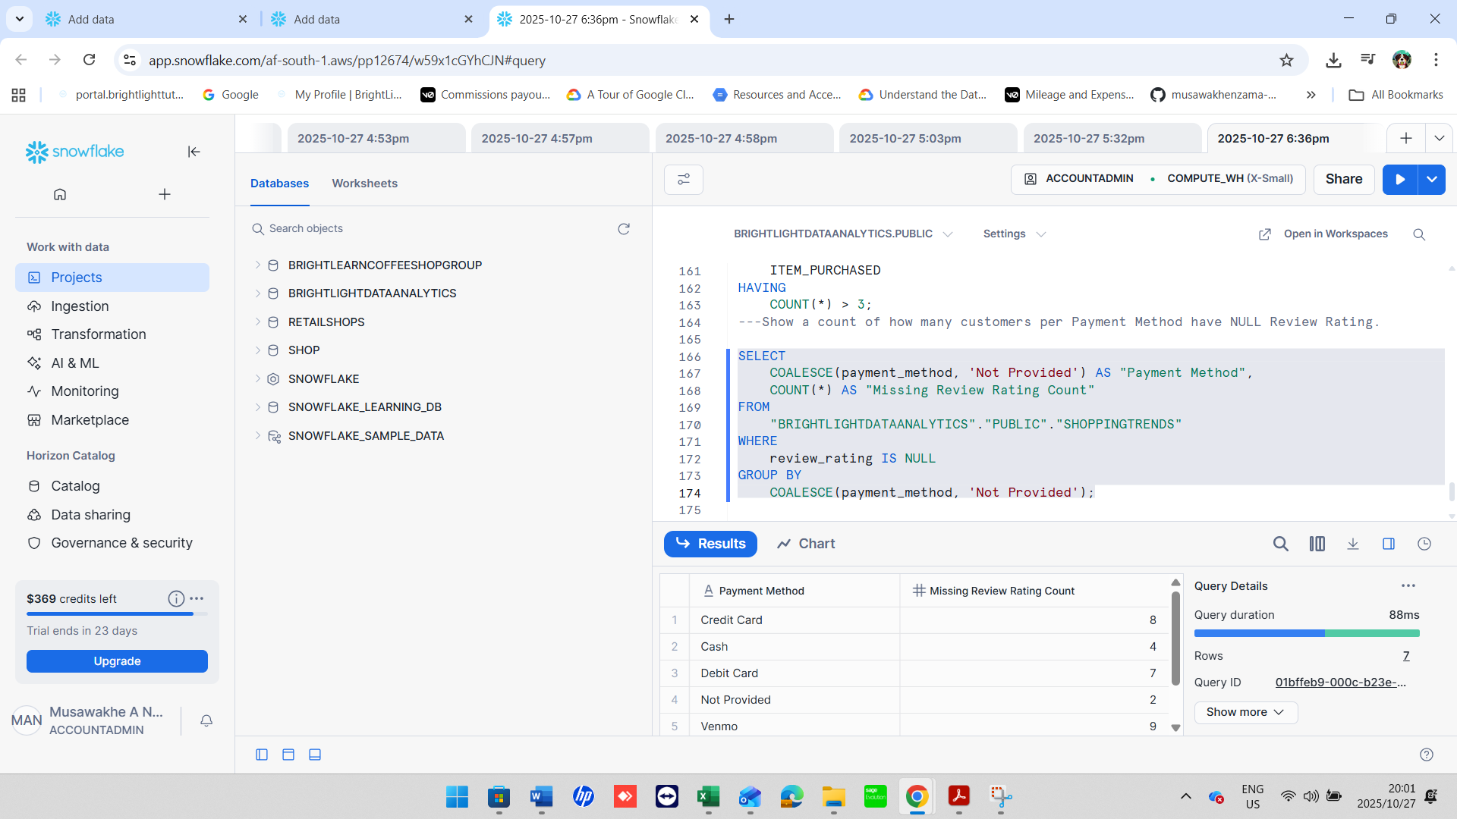

1. Group by Category and return the average Review Rating, replacing NULLs with 0, and filter only where the average is greater than 3.5.

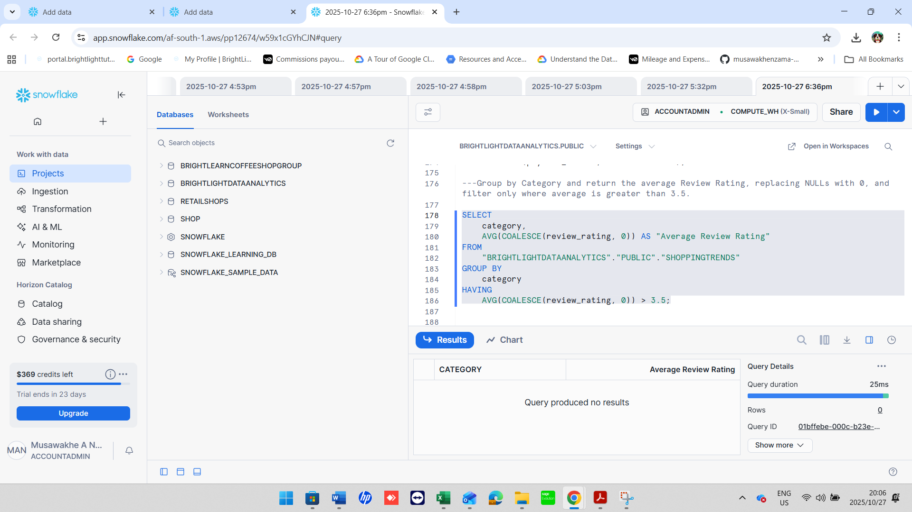

1. List all Colors that are missing (NULL) in at least

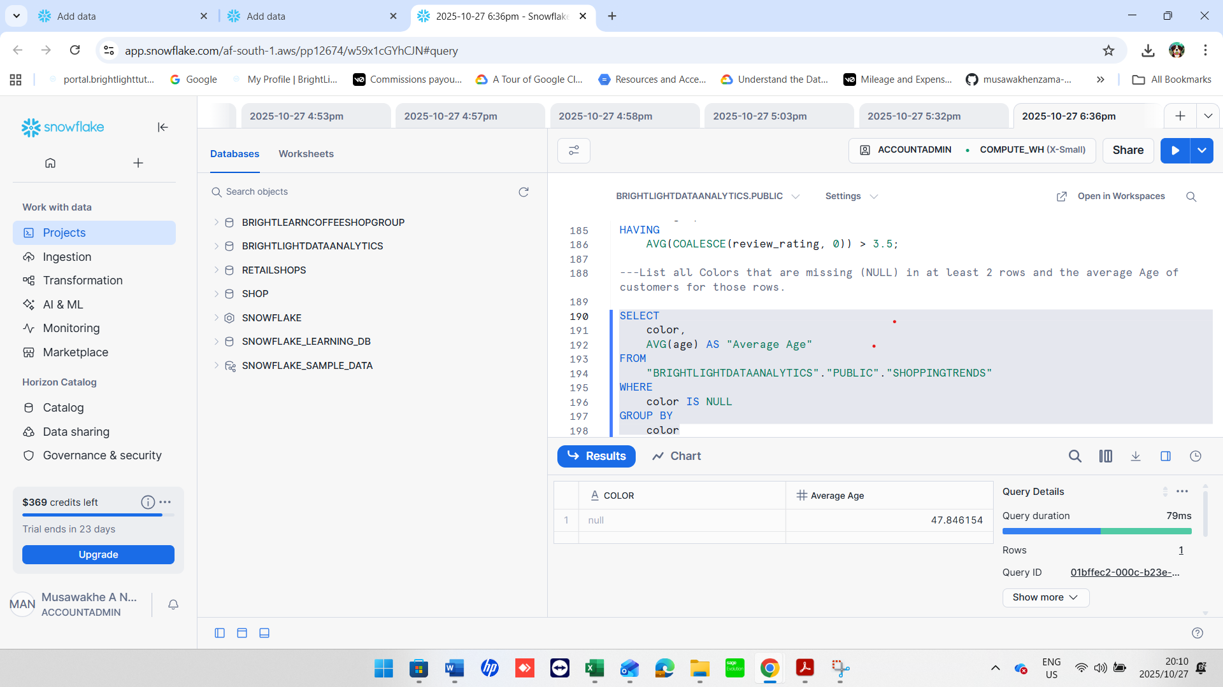

1. Use CASE to create a column Delivery Speed: 'Fast' if Shipping Type is 'Express' or 'Next Day Air', 'Slow' if 'Standard',

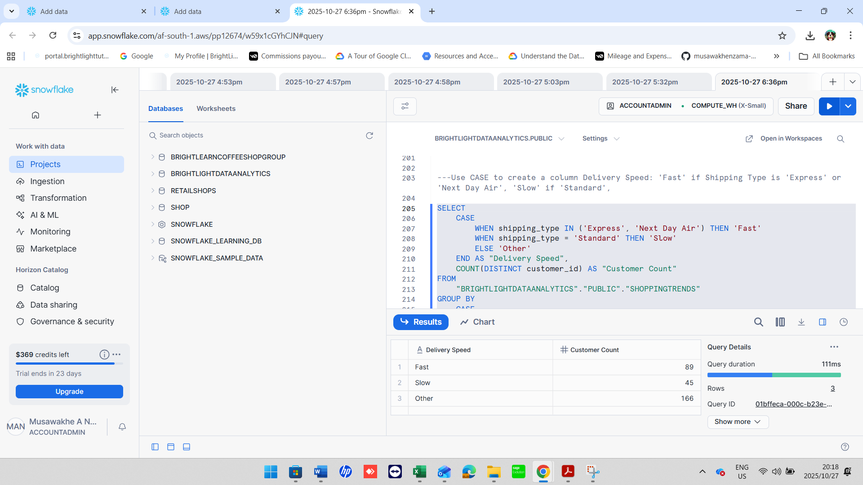

1. Find customers whose purchase_amount is NULL and whose Promo Code Used is 'Yes'.

1. Group by Location and show the maximum Previous Purchases, replacing NULLs with 0, only where the average rating is above 4.0.

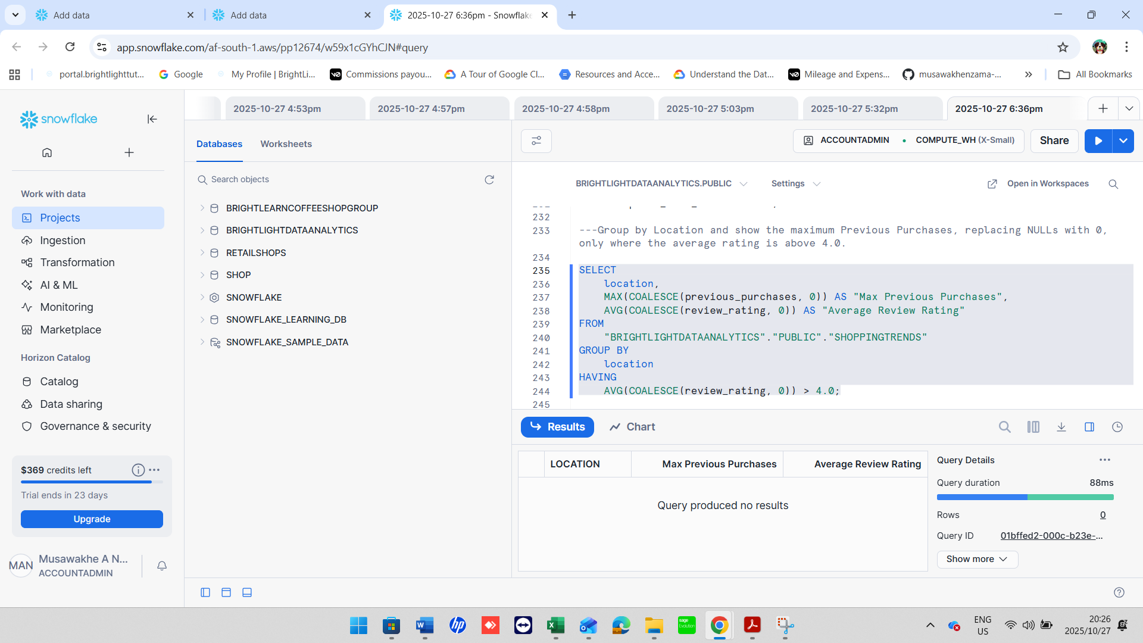

1. Show customers who have a NULL Shipping Type but made a purchase in the range of 30 to 70 USD.

